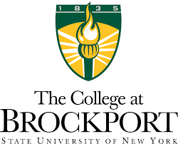

Building a Better Brockport:
The College’s Strategic Plan, 2017-22
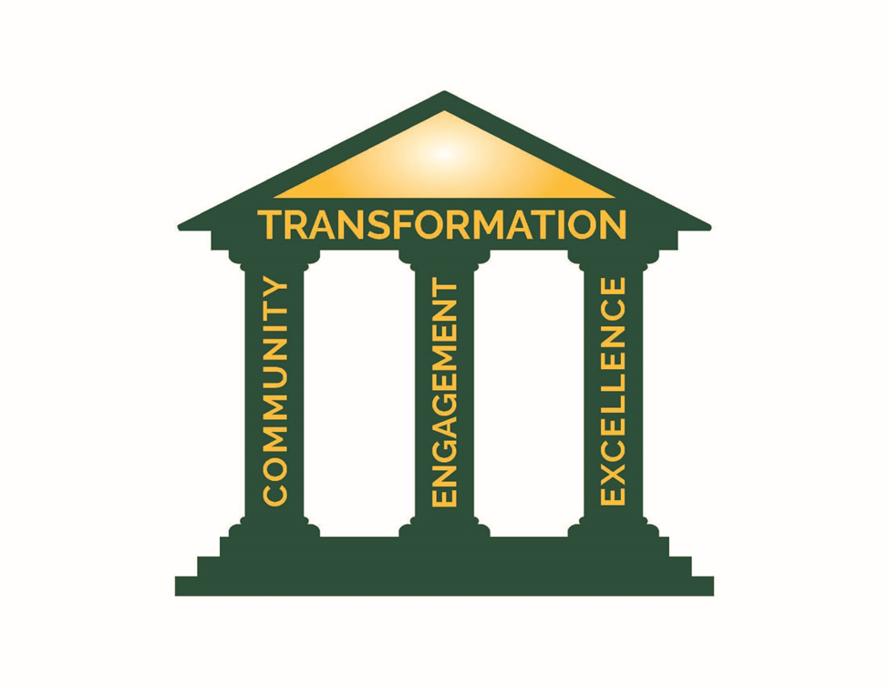

Mission

The College at Brockport is an inclusive learning community that inspires excellence through growth, engagement, and transformation.

Vision

Building meaningful lives and vibrant communities

Values

Community • Engagement• Excellence• Transformation

The Brockport Promise
The College at Brockport promises to engage our students each day in cultivating their capacity for intellectual, physical, and creative accomplishment.

Background to Building a Better Brockport

Building a Better Brockport is the work of dedicated individuals across and beyond campus. The College intends for this to be a living document that guides our behavior and commitment over the next five years and beyond. It should be read in concert with the operational plan that references specific, institution-wide measures that will be tracked, reviewed and assessed.

Building a Better Brockport has its genesis in a series of Vision Cafes that were held in the fall of 2015. These Vision Cafes asked our campus community to reflect on the previous strategic plan, the College of 2025 conversations, and our collective vision for the future. More than 200 people participated in these face-to-face discussions, with more than 100 also participating via an online survey. In relation to the aspects of the 2011-16 plan that still resonate, it was clear that the vast majority supported the principles of two of the four College priorities outlined there, namely

- Engaged students and academic quality
- Learning environment and quality of place

Building a Better Brockport takes this feedback into account and transforms these goals to fit with the changes that have taken place since 2011.

In February 2016, the Strategic Planning Committee commenced their thoughtful and dedicated work. By the end of the spring semester, it was clear that four areas of focus had emerged: community, engagement, excellence, and transformation. In September 2016, subcommittees were formed to focus on these areas, as well as to work on new Mission, Vision, and Values. Through online surveys, town hall meetings, community forums, and presentations, both on and off campus, all members of the campus community have had an opportunity to engage with, respond to, and offer ideas on specific areas. Outside of the work of the committees, there were more than 900 active participants in the process. The College is grateful to our colleagues, students, and community members for their advice, guidance, and enthusiasm.
Message from President Macpherson

This strategic plan builds upon the longstanding achievements and goals of the College and sets a new direction that expands our reach further into our community. We span the urban and the rural, and we take pride in our ability to address and enhance both aspects of our local community. We are Rochester’s SUNY and Brockport’s SUNY, and we are more than this, too. As a College, we believe in a greater Brockport for a greater Rochester, and a greater Brockport for a greater world. We are of our community, not just in our community, and over the next five years, we will become recognized as a key resource for Monroe County and beyond.

The College at Brockport has a small school feel, but offers big school opportunities for our students. As we tell the story of the successes of our faculty, staff, students, and alumni, we will connect and engage with non-profit organizations, business leaders, and educational institutions at all levels to assist our community and act as a resource for solutions and innovations. We recognize the remarkable range of expertise that lies within our boundaries, and we seek to expand outwards so as to share that expertise more widely.

We will align resources to our strategic planning priorities, and ask divisions, offices, and departments to articulate how their goals fit within the broader framework of Building a Better Brockport. We know that you are best placed within your units to decide how you fit into this framework, and we are confident that this plan will allow your area to focus on its strengths and opportunities.

What follows is a distillation of the work of the campus. It sets the direction for the future.


Heidi Macpherson
President
The College at Brockport, February 2017

Building a Better Brockport

The College at Brockport provides an exemplary undergraduate and graduate public education, encompassing liberal arts and professional programs. We aim to cultivate the skills and knowledge, critical inquiry, innovation, and resilience necessary to transform society. In doing so, we support our faculty and staff in their pursuit of excellence in teaching, scholarship, creative endeavors, service, academic support, and engagement in the College, and our wider local, regional, state, national, and global communities.

Our achievement of these ambitious goals requires a framework, dedicated resources, and a clear assessment plan. Building a Better Brockport offers this framework, with the knowledge that the institution-wide goals described here will be supported and enhanced by unit-level operational plans, more specific metrics, and a robust assessment plan.

All of the strategic plans of the College will fold under this plan. Moreover, this plan works in concert with SUNY-wide plans and will be a dynamic, living document that is reviewed regularly and revised as appropriate, given changing political, economic, social, and technological landscapes. As the next Chancellor of SUNY develops additional frameworks for the System, Building a Better Brockport will adapt accordingly, while remaining true to the core values of community, engagement, excellence, and transformation. These values offer a supportive framework for our College and are further defined below.

COMMUNITY
The College at Brockport fosters a diverse community within which every member plays an essential part in ensuring an inclusive and sustainable environment in which to learn, work, and live. We are dedicated to cultivating deliberative communication, enhancing connections across disciplines and cultural differences, and engaging with local and global partners.

ENGAGEMENT
The College at Brockport is committed to engagement—faculty and staff engaging with students in purposeful and rewarding educational activities; faculty and staff engaging in their professions and service; faculty, staff, alumni, and students engaging in the activities of the local, regional, national, and/or global communities. We are dedicated to fulfilling our individual and collective obligation to offer meaningful and intentional learning opportunities that promote intellectual, professional, and interpersonal development. These experiences contribute to the achievement of learning outcomes, scholarly accomplishments, professional growth, and quality of place.

EXCELLENCE
A culture which uniformly inspires all to excellence is essential to achieving our mission. The College at Brockport defines excellence as all members of the Brockport community uniquely achieving their maximum potential and contribution in everything they do. The success of students, faculty, staff, and alumni, and their long-term affinity with the College, will affirm that a culture of excellence has been achieved.

TRANSFORMATION
The College at Brockport recognizes transformation as the aim of education. Signifying deep, sustainable, and meaningful change and growth, transformation is a journey of continual improvement rather than a destination to be reached in a prescribed timeframe. Transformation is not just a core value, but also a wider framework unifying the other three—community, engagement and excellence.

We are committed to making The Brockport Experience transformative for all students, faculty, staff, alumni, and any individuals and communities that come in contact with the College.
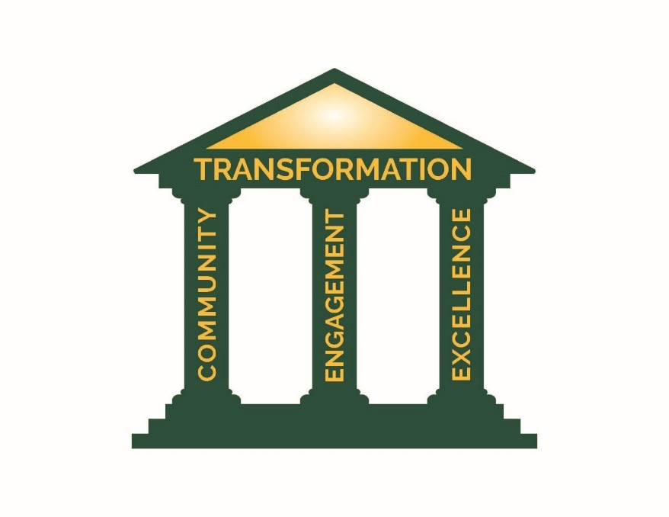

Goals of Building a Better Brockport
Our enduring foundational values of community, engagement, excellence, and transformation function as pillars that underpin and extend through Building a Better Brockport. They set the framework for the four goals we will work together to achieve.

- To be a Great College at which to Learn
- To be a College engaged with its Community
- To be a Sustainable Institution for the 21st Century
- To be a Great College at which to Work
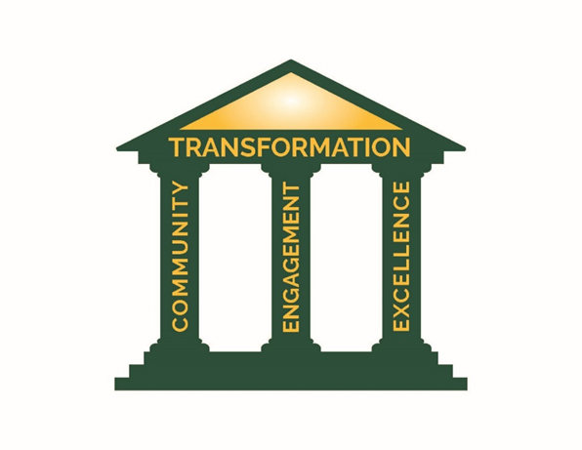

Goal 1: To be a Great College at which to Learn
A great college at which to learn is an institution that provides an excellent educational experience to both graduate and undergraduate students that is relevant and rigorous, shaped by the evolving and emerging needs of students related to their backgrounds/experiences, and amenable to innovation using evidence.

A great college at which to learn has faculty and staff who act as role models, establish high expectations, demonstrate care for their students, and employ evidenced-based teaching practices, such as assessment of student achievement.

A great place to learn entails full inclusivity for all students, as well as the knowledge and skills gained from a diverse student, faculty, and staff body, and a diverse set of perspectives and cultural knowledge.

A great college at which to learn recognizes that there are several different loci of learning―among them, classrooms, laboratories, the library, residence halls, and the community—and embraces different forms and modes of instruction―text-based, classroom-based, online, hybrid, distance learning, applied, fieldwork, and independent.

A great college at which to learn has a learning environment with structures, tools, and conditions that support the needs of every learner, fosters collaborations, and builds relationships needed for teaching and learning. We support the assessment of coherent student learning outcomes to ensure continual improvement.

In relation primarily though not solely to graduate students, a great college at which to learn infuses the latest research into the curriculum, demands and expects high level analysis and engagement, uses discipline-based learning, develops professional practice, and supports the co-creation and co-curation of knowledge.

In relation primarily to undergraduate students, a great college at which to learn embraces nationally-recognized High Impact Practices (HIPS) and institutionally-specific Co-Curricular High Impact Practices (CHIPS). These efforts are enhanced by effective support systems that engage students from recruitment to graduation, and enable them to undertake advanced degrees and/or engage in meaningful work.
Our institutional investment in HIPS and CHIPS complements our focus on classroom-based learning, online education, and hybrid models. We value and support all educational opportunities that engage students in their active learning, at both graduate and undergraduate levels. We support our teaching faculty in their professional development through our Center for Excellence in Learning and Teaching (CELT) and through our Academic Systems Integration and Support team.

Our Brockport Promise is premised upon our College being a great place to learn.

MEASURES OF SUCCESS:
- We will expand, develop and assess academic, co-curricular, and operational activities proven to elevate the ability of both graduate and undergraduate students to create their best Brockport experience and shape their futures as engaged citizens and alumni.
- We will revise and further develop the Academic Master Plan, to ensure that resource allocation facilitates sustainable improvements in program quality. This will include, where appropriate, the development of online degree completion programs.
- We will grow the number of grants applied for and received, especially those that support our students’ learning and engagement.
- We will see growth in the number and percentage of graduate students who conduct original research, attain external funding or publications, and/or who are professionally prepared for their careers, as determined by alumni surveys and other measures.
- We will ensure that all undergraduate students, including transfer students and non-traditional students, have the opportunity to undertake multiple HIPs and CHIPs and have these experiences identified on their academic and co-curricular transcripts.
- We will raise private funds to aid students’ ability to experience internships, study abroad or international exchange opportunities, and undergraduate research opportunities. As a result, financial need alone will not preclude students from enhanced educational experiences.
- We will meet or exceed the Access, Success, Completion, Inquiry and Engagement Targets of the College’s current SUNY Performance Improvement Plan or any subsequent SUNY performance plan.
- Our campus climate data will show continual improvement, and, based on assessment results, resources will be dedicated to addressing issues of diversity in the curriculum and in faculty/staff representation, as well as equity in student retention, completion, and opportunity. We will make demonstrated progress towards the Equity, Diversity, and Inclusion (EDI) goals outlined in the Strategic Plan for EDI.
- We will meet or exceed the requirements of accrediting agencies in relation to both our accredited graduate and undergraduate programs.
- We will seek continual improvement in external measures, such as the Princeton Review, NSSE, or US News and World Report surveys. Each cycle, we will assess which external measures offer the best validity and relevance to our focus on being a great college at which to learn.
Goal 2: To be a College Engaged with its Community
Community engagement results from the purposeful collaboration between institutions of higher education and their larger communities (local, regional/state, national, and global) for the mutually-beneficial exchange of knowledge and resources in a context of partnership and reciprocity.

Community engagement offers the opportunity to contribute to the public good by combining the resources of the College with those of other public and private sectors to enrich scholarship, research, and creative activity; enhance curriculum, teaching, and learning; prepare educated and engaged citizens; strengthen democratic values and civic responsibility; and address critical societal issues.

To be a college engaged with its community requires that we promote, support, recognize, and celebrate the service and engagement of faculty, staff, students, and alumni in local, regional, national, and international communities, demonstrating our commitment to leadership, civic engagement, and global awareness.

To be effective in our engagement, we must also act as a community on campus, supporting and recognizing equity, diversity, and inclusion as key priorities.

Engagement also requires that we promote dialogue and collaboration across departments and divisions, recognizing and supporting the opportunities that come from inter- and cross-disciplinary work. Intercultural competence remains key to engaging our communities in a successful way.

MEASURES OF SUCCESS:
- We will see growth in the number and extent of engagement partnerships with the Village of Brockport, City of Rochester, Monroe County, and local rural communities, through active participation in some or all of the following: community advisory boards and volunteer efforts; Town/Gown meetings and initiatives; collaborative events; community internships and partnerships. This will allow us to explore and assess strong community partnerships around areas of critical need, e.g., the development of a community clinic.
- We will develop stronger working relationships with bodies with influence, including some or all of the following: the Finger Lakes Regional Economic Development Council (FLREDC), the Greater Rochester Chamber of the Commerce, the Greater Rochester Enterprise (GRE), the Rochester Monroe County Anti-Poverty Initiative (RMAPI), and state and national bodies of relevance to the College.
- We will expand campus-based Lifelong Learning opportunities for community members.
- We will ensure increased opportunities to link all students, including international students, with community support.
- Building on our history and genesis as an institution of higher learning, we will promote increased collaboration with P-12 schools in Brockport, the Rochester City School District, and other local schools (in and out of Monroe County), including private and charter schools, as well as our affiliated REOC, and our local community colleges.
- We will see increased interdivisional and interdepartmental communication around scholarship, curricular and co-curricular events and achievements.
- We will ensure enhanced alumni and external engagement, providing for social and networking activities, and inclusive of meaningful opportunities to contribute time, talent, and funding to the College.
- We will work to achieve Carnegie Foundation Elective Community Engagement Classification or a similar external measure.

Goal 3: To be a Sustainable Institution for the 21st Century
The College at Brockport sees sustainability, long linked with environmental concerns, as also encompassing our fiscal health and viability. More than ever, the College must recognize the internal and external factors that influence how and why diverse students select the college at which they want to study and their desire to achieve on-time degree completion. Accordingly, we will identify, assess, modify, and/or establish key systems and processes to ensure degree value and the long-term viability and success of our institution. One example of this is the use of predictive analytics to identify patterns and/or mitigate problems related to the financial aid needs of students, enrollment and successful completion of courses, different modes of instruction and pedagogical strategies, and retention and degree completion.

To be a sustainable institution in the 21st century requires being aware of and responsive to extant and emerging modes of teaching and learning as they relate to the success of all students in general and graduate students in particular so that they may contribute to the economic development of the region and state. It also requires providing support services necessary for successful program completion are available, including online tutoring, proctoring services, and library/research.

As noted in our Environmental Sustainability Policy, the College has committed to being “a positive and innovative force for the protection and enhancement of the local, regional and global environment, through teaching, research and administrative operations.” We have committed to promoting “a sustainable future by performing actions that are ecologically sound and economically viable, thereby raising the awareness of the College community to both local and global environmental issues.”

Environmental sustainability requires a focus on the health and safety of the environment of our campuses as well as the quality of place and accessibility. It means focusing on environmentally responsive facilities planning and design, environmental literacy and education, sustainable procurement, and a minimization of waste. Part of our sustainability goal is to ensure that we are not only environmentally conscious, but also environmentally proactive.

To ensure fiscal sustainability of our College, and advance the priorities of Building a Better Brockport, we will revise our resource allocation methodologies and budget processes, moving away from incremental, annual budgeting to a gainsharing principle that rewards initiative. A multi-year undertaking involving extensive consultation with the campus community will result in guidance regarding the appropriate allocation of revenues, the assignment of set costs, and the incentivization of divisional priorities in alignment with the College’s strategic goals. This budget model will be refined, as appropriate, using assessment data and results.

This new financial model will serve as a roadmap that governs how resources flow on campus to increase transparency, simplification, and incentives for Building a Better Brockport.

In addition, further development of the Physical Master Plan will match investments to the curricular and degree plans outlined in the Academic Master Plan, so that we are anticipating, rather than merely reacting to, changes in the needs of the state and the nation.

MEASURES OF SUCCESS:
- We will achieve and then maintain a higher Sustainability Tracking, Assessment and Rating System (STARS) level.
- We will enact a new budget model that incentivizes innovation and strategic priorities.
- We will revise and further develop the Academic Master Plan, to ensure that resource allocation facilitates sustainable improvements in program quality. This will include, where appropriate, the development of online degree completion programs.
- We will revise our Physical Master Plan so that it supports the Academic Master Plan, the Residence Life Plan, and sustainability objectives.
- We will develop and establish appropriate emergency preparedness, business continuity, record management, and information recovery plans for all campus operations.
- We will aim to maintain and, where feasible, expand our accreditations.
- We will achieve Middle States Criteria Accreditation with Commendation.

Goal 4: To be a Great College at which to Work
A great college at which to work has a healthy campus climate and a culture of excellence where its employees have pride, enjoy working, and have trust in the institution and each other.

Innovation, agility, resilience, and efficiency are the hallmarks of such a college, and trust is the prerequisite for its success. A great college at which to work is characterized by honesty, credibility, respect, fairness, pride, camaraderie, and an appreciation of equity, diversity, and inclusion as underpinning principles for all that we do.

A great college at which to work acknowledges that its faculty and staff are its most important assets. As a result:
- Faculty and staff are genuinely appreciated and rewarded for their efforts.
- Faculty and staff are provided with opportunities for skills and knowledge development on an ongoing basis.
- Leaders function more as mentors than managers, and leadership is practiced at all levels of the institution (including by individuals without management responsibilities).
Engagement in scholarship, professional development, certificate programs, and training demonstrates an investment in the growth and achievement of faculty and staff, who in turn provide a high quality environment for our students.

Promoting a culture of engagement across divisions, departments, and disciplines complements the College’s goals to build a more inclusive campus community. Faculty, staff, and students will work in partnership to advance goals related to inclusion, creating an environment where all members of our community are respected, valued, and included.

MEASURES OF SUCCESS:
- We will create, improve, and sustain activities that purposefully engage senior leaders with all key stakeholders and organizational systems, ensuring that our leaders have the best opportunity to understand, mentor, communicate, and inform governance at The College at Brockport.
- Our campus climate data will show continual improvement, and, based on assessment results, resources will be dedicated to tackling long standing issues of equity and inclusion, particularly in relation to the recruitment of and institutional support for a diverse faculty and staff body. We will make demonstrated progress towards the Equity, Diversity, and Inclusion (EDI) goals outlined in the Strategic Plan for EDI.
- We will undertake continual review, assessment, and improvement of faculty and staff onboarding and training programs, including for temporary employees. These include, but are not limited to, new faculty workshops, new chair workshops, CELT workshops, and ongoing training to keep up with legal obligations and best practices.
- We will achieve excellent and effective working relationships with shared governance and our organized labor to ensure a safe, fair, and inclusive campus, free from workplace bullying, and transparent in its introduction, revision, and assessment of policies that impact our community.
- We will undertake a comprehensive pay review that will compare faculty and professional staff salaries against College and University Professional Association (CUPA) and other relevant nationally-normed data. A long term strategy will be developed to deal with compression and inversion issues. In addition, the College will strive to provide locally defined pay options, where feasible and fair.
- We will seek continual improvement in the financial support for faculty research engagement, including internationally. This may be funded by private sources.
- We will develop further our “Investing in Our People” Leadership Development Series.
- We will demonstrate continual improvement based on institutional assessment and accreditation evidence.
- We will ultimately achieve The Chronicle of Higher Education Recognition as a Great College to Work For or similar external measure.

The Brockport Experience

The object of transformation is The Brockport Experience—the aggregate, day-to-day, and ongoing experiences of the Brockport community: our students, faculty, staff, alumni, visitors, and the broader society (local, regional, national and global communities). This is an enterprise-wide concept, spanning the multiple entities that comprise The College at Brockport (the Divisions and Schools of the College, the Rochester Educational Opportunity Center, the Brockport Auxiliary Services Corporation, the Brockport Foundation, the Brockport Alumni Association, and the Research Foundation).

The goals of Building a Better Brockport are the framework by which the threads of The Brockport Experience come into alignment and reinforce one another so that the whole becomes greater than the sum of the parts, strengthening and giving clarity to The Brockport Experience.

Led by Debbie Jacob and Deb Toms, the Vision Cafes were also facilitated by the following faculty and staff: Sherrill Anderson, Laurie Freeman, Joe Goings, Dale Hartnett, Tom Hernandez, Anna Hintz, Sara Kelly, Cindy Krautwurst, Randall Langston, Kim Piatt, Adam Rich, Chaley Swift, and Celia Watt. Thanks are due to them for the time and energy they put in to supporting the goals of engagement and communication.
See Appendix A for a summary of findings.
For a list of members of the committee and the subcommittees, please see Appendix B. Thanks are due to Laurie Smith and Julie Pruss for their comprehensive administrative support, as well as Mary Ellen Zuckerman and Faith Prather, who were members of the committee in the first semester of our work.
275 individuals completed the online surveys on the draft mission, vision, and values, and the four pillars, as they were then called. Town Halls averaged an attendance of over 200 each on campus and were streamed to the MetroCenter and the Rochester Educational Opportunity Center (REOC). In addition, many more individuals attended the open forums held by pillar leaders which ranged in numbers between 3 and 50. The inaugural Campus Leadership Summit had 120 attendees, and 178 individuals responded to the draft plan online. In addition, several divisions and departments specifically responded to the draft document.
In Appendix C and in our online repository of strategic planning resources, we offer some exemplars and specificity that units may wish to adopt as they develop their own plans.
Including, but not limited to, the Strategic Plan for Equity, Diversity and Inclusion (EDI), the Strategic Retention Plan, the SUNY Performance Improvement Plan, the Academic Master Plan, The Environmental Sustainability Policy, the SUNY Applied Learning Plan, the Institutional Assessment Plan, the Affirmative Action Plan, the Facilities Master Plan, the IT Strategy and Roadmap, the next Comprehensive Campaign in support of institutional priorities, and the Alumni Engagement Plan. In addition, as the Division of Administration and Finance develops its Administrative Roadmap over the next five years, this, too, will be in alignment with Building a Better Brockport.
The 10 HIPS as defined by AAC&U’s report, High-Impact Educational Practices (George D. Kuh, 2008), include First-Year Seminars and Experiences, Learning Communities, Writing-Intensive Courses, Collaborative Assignments and Projects, Undergraduate Research, Diversity/Global Learning, Service Learning, Community-Based Learning, Internships, Capstone Courses and Projects, each of which is available for Brockport students. Our institutionally based CHIPS include our award-winning Leadership Development Program; our expanding Living/Learning Communities, which have a tremendous positive impact on student retention; membership in our student athletics teams and sports clubs; student organizations and clubs; peer mentoring; and Volunteering and Community Service; Residential Developmental Curriculum; Healthy Campus programs; Student Employment; and Rituals and Traditions that inculcate a sense of pride and a shared understanding what is important as a member of the College community.
Brockport's Performance Improvement Plan
The American Association of Colleges and Universities (AAC&U) has endorsed this definition of intercultural knowledge and competence: “a set of cognitive, affective, and behavioral skills and characteristics that support effective and appropriate interaction in a variety of cultural contexts” (Bennett 97). See Bennett, J. M. “Transformative Training: Designing Programs for Culture Learning.” Contemporary Leadership and Intercultural Competence: Understanding and Utilizing Cultural Diversity to Build Successful Organizations. Ed. M. A. Moodian. Sage: Thousand Oaks, CA, 2008: 95-110.
The College at Brockport’s Environmental Sustainability Policy

